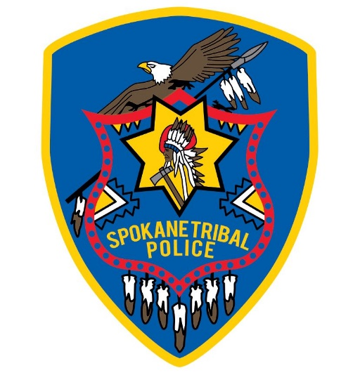

Spokane Tribal Police
January Report 2023

The New Year is here and we are excited for the changes to come!
We have begun the Spillman computer upgrade process and have training scheduled for all members of the department in February.
Work on the repeaters is continuing to enhance our communications through out the reservation for emergency services.
Our department is moving forward with training for all members which includes Leadership, Background investigations, Spillman computer training, Lexipol policy training and many more.
We began with mounting the computer stands in the vehicle in preparation of deploying laptops in February.

The January Entry Level Police Officer hiring process is closed for the first round and interviews will be conducted in February. We received 8 applications.

Please remember, the Spokane Tribal Police Department responds to all calls for service that are called into the Communications Center located at the Public Safety Building. We DO NOT get our information about incidents occurring from Facebook or any other social media. When something is posted to social media, it only delays what could be a response for something we could handle at the moment it happens, so please call the Police Department at 509-258-4400

Remember, our Drug Tip line is answered by the drug detective only.
Your anonymity is safe. Please, if you see something, say something.
Our entire community needs to help, it is making a difference!
Drug Tip Line 509-202-5541

