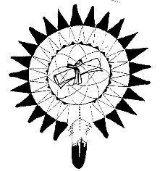

Spokane Tribe Education Department

Release of Information
Aly Peone, Program Manager; Mariah Stearns, Outreach Coordinator
P.O. Box 358 - Wellpinit, WA 99040 - Ph #: (509) 458-8005 - FAX: (509) 458-8017

Under the Federal Privacy Act of 1974, Federal Agencies cannot release your personal information without your authorization and the Spokane Tribe Education Department is subject to these restrictions.
Restrictions without signature include: access to financial aid information, student file at your educational institution, student file at STOI Education Department, etc.
To release those restrictions, I have signed and consented to this release of information that will allow the Education Department staff to explore alternative sources of assistance that may aid in the individual student. In addition to collaborating with third parties (parents, guardians, school representatives) that may allow them to assist myself in my educational endeavors. I understand that my application and records will be kept confidential.
I have read and understand that the above statement regarding my Privacy Rights and the purposes for which information about me will be used by the Spokane Tribe Education Department staff.
I authorize the release of information about myself and my educational background to the Spokane Tribe Education Department staff to help me secure financial assistance.
In addition, I authorize ___________________________ (print name) to have access to my STOI Education records and relevant information, or else all records and relevant information pertaining to my file will not be released without prior written consent.

Authorized Person First and Last name (printed) ^{(required)} Date

Authorized Person First and Last Name Signature ^{(required)} Date

Student First and Last Name Signature (printed) ^{(required)} Date
Student First and Last Name Signature ^{(required)} Date

